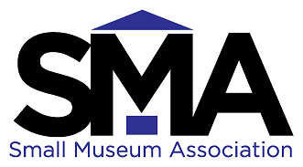
Small Museum Association
36th Annual Conference
February 16-18, 2020

Award Information

The Small Museum Association (SMA) recognizes two museum professionals each year at its conference by selecting them for awards. The two awards available are:

- The Hunter-Burley Award, which recognizes an individual’s outstanding contributions to the advancement of public access and professional growth for an individual institution

and

- The Small Museum Association Award, which celebrates an individual’s outstanding contributions to the advancement of funding for, professional growth within, and/or the accessibility of information to the small museum community on a regional or state level.

Nominating a colleague for either of these awards is an excellent opportunity to publicly acknowledge their hard work at one museum or in the small museum field. Submit the form below by December 20, 2019 to celebrate the accomplishments of a deserving small museum professional.

Small Museum Association
36th Annual Conference
February 16-18, 2020

Nomination Form
Your Information:

Name______________________________________________________________

Museum Affiliation__________________________________________________

Address____________________________________________________________

__________________________________________________________________

E-mail Address______________________________________________________

Phone Number______________________________________________________

Information About the Nominee:

Name______________________________________________________________

Museum Affiliation__________________________________________________

Address____________________________________________________________

__________________________________________________________________

Phone Number______________________________________________________

E-mail Address______________________________________________________

Nomination for:
☐ Hunter-Burley Award ☐ Small Museum Association Award
Please summarize, in one page or less, why you feel the nominee should be recognized with this award. Include information about their current position at their institution and the impact they have made within it. For the Small Museum Association Award, include information about their contributions to the larger museum community. Are they an innovative thinker? A great communicator? Do they spend every waking hour thinking about the future of small museums? Tell us what makes them unique and award-worthy.

Application Deadline: December 29, 2018
Mail Completed Form and Recommendation Letter to:
SMA Conference Committee, c/o Rachel Nichols
62 E. Baltimore Street
Hagerstown, MD 21740
E-mail: scholarships@smallmuseum.org

